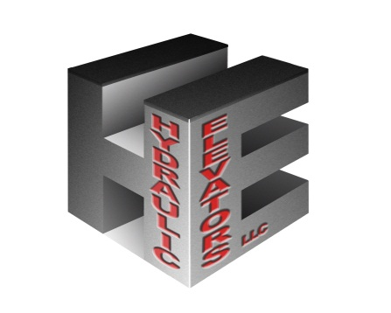
HYDRAULIC ELEVATORS, LLC
94 Valley Hill Road
Riverdale, Georgia 30274
Tel: 770-478-8344
Fax: 770-473-0296
Email: info@hydraulicelevatorsllc.com

CYLINDER ASSEMBLY INSTRUCTIONS: MULTIPLE PIECES

**When steel cylinders are placed underground, they may be subject to rapid corrosion due to chemical or electrolytic action or both. The rate of deterioration varies at each location. Hydraulic Elevators LLC, cannot assume liability for cylinder failure due to installation in a destructive environment. **

NOTE: Clean internal and external threads thoroughly. If joint is to be welded, see below. Align both sections and screw together as tight as possible. Weld upper edge of coupling to pressure tight. Weld with two complete passes and stagger welds from side to side to prevent warping. Cover bare metal with protective coating. When cylinder is suspended in the hoist-way, check for straightness using lining wire stretched along the side of the cylinder. This should be done at two points, 90 degrees apart. Straighten if deviation is more than 1/8”.

To straighten, apply heat with suitable torch to the cylinder on the high side. An area about 2” in diameter on the cylinder, heated to a dull cherry red will give a correction of about ¼” of the average length. Heat should be applied as rapidly as possible to prevent spreading. When heated, the error will increase on the high side temporarily. After the part has cooled, the correction will be noted. Make a final check for straightness after the cylinder has completely cooled.

Plumb the cylinder by lowering into the hole and resting on the leveled, blocked up pit beams. Locate the jack assembly and block up and level the pit beams to the height shown on the layout. Use a weighted spider of a sheet metal disc about 1/16” smaller than the inside of the cylinder, and a wire or line fastened to the exact center. Suspend the spider from a pulley as high above the cylinder as possible and directly above the correct location of the center of the cylinder. Lower the spider just clear of the bottom of the cylinder and then adjust the bottom of the cylinder using pit bracket leveling screws to bring the plumb line to the center of the cylinder.

Check for a bend in the cylinder by slowly raising the spider to the top. Any bend will force the line out of center at the top. Back fill carefully, uneven back filling and tamping can force a bow in the cylinder.

NOTE: Cylinders being installed with tapered threaded couplings can use X-Pando pipe sealant instead of being welded.

Cylinders being installed with straight threaded couplings must be welded under all circumstances. These cylinders are marked accordingly.

NOTE: It is recommended that couplings be preheated to approximately 350 degrees (light blue) before welding with a low Hydrogen rod such as AWS7018.

**Hydraulic Elevators, LLC recommends welding all cylinder joints for the best quality performance. Hydraulic Elevators, LLC cannot accept responsibility for improperly installed cylinder assemblies.**

